OFFER LETTER

Date: 22.01.2023

To,
Mr. Pavan T
Hyderabad.

Dear Ms. Devyani Sameer Kawade
This is with reference to your interview held on 20-01-2023, we are pleased to inform you that you have been shortlisted for the position of Trainee UX Designer at CTC 3,10,000/-per annum.
Your date of joining will be 22-01-2023 and you will report to the Chief Technical Officer.
You will be posted at our Hyderabad office and you will have a 7-day trial period and a 2-month probationary period, based on your performance during the probation period your services will be confirmed further or will be ended by the employer.
Further you are requested to submit the below documents soft copy at the earliest before your joining date.
- Copies of Educational certificates.
- Copy of ID proof and address proof.
- Previous organization appointment/offer letter, last 3 months pay slips and Experience/Relieving letter.
- Bank account details – Cancelled Cheque/ passbook copy.
With Best Wishes!

For PIXLIFY Internet Solutions

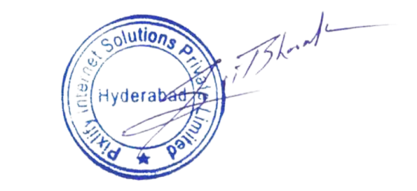

Mr. Bharat Gupta

CEO

ANNEXURE

Description | MONTHLY | ANUALLY
Basic salary | 12,950 | 1,55,400
HRA | 6,475 | 77,700
Special allowance | 4875 | 58500
Travel allowance | 1,600 | 19,200
GROSS SALARY | 25,900 | 3,10,800
PT Deduction | 200 | 2400
NET SALARY | 25,700 | 3,08,400

